**Week 3: Spring Data JPA with Spring Boot and Hibernate Hands-On Tasks**

Student Name: Jitesh Sen

Email: [jiteshsen2002@gmail.com](mailto:jiteshsen2002@gmail.com)

Superset ID: 6387362

✅ ***Spring Data JPA Quick Example***

I built a Spring Boot application to connect with a MySQL database and fetch country data using Spring Data JPA and Hibernate. The initial test fetched a list of countries from the database and displayed them through a REST API.

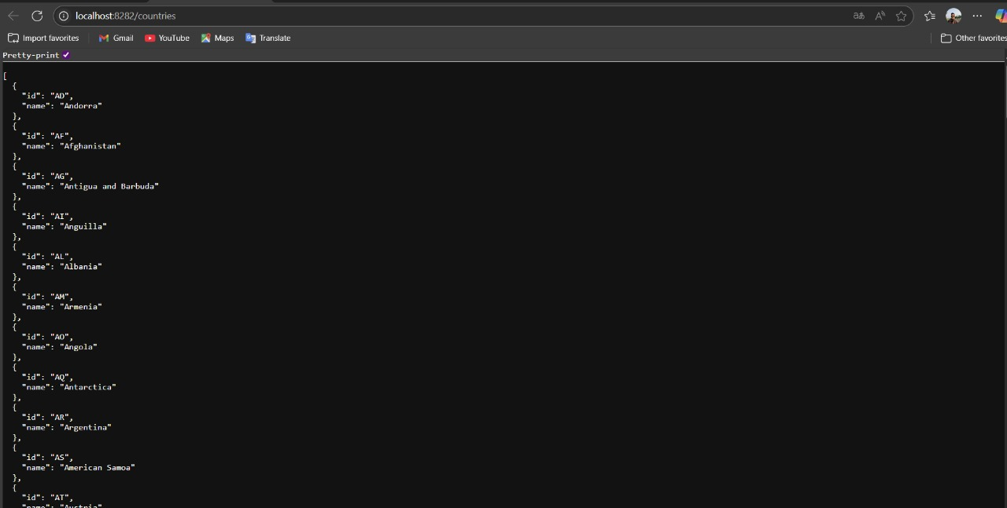

✅ ***Hands-On 6: Find a country based on country code***

I added a REST endpoint to find countries by their code using path variables, handling the “not found” case gracefully with a custom exception.

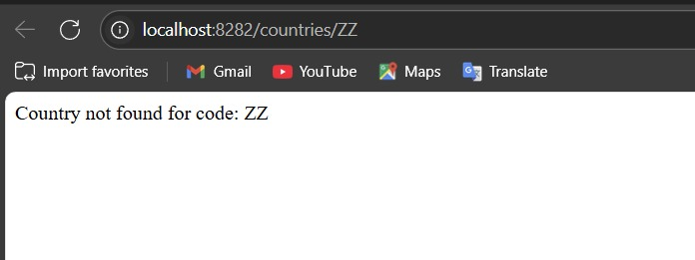

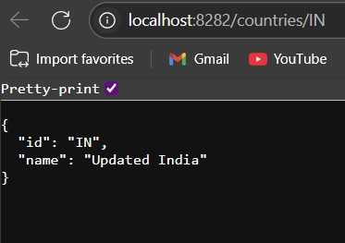

✅ ***Hands-On 7: Add a new country***

I implemented a POST endpoint that accepts a JSON payload to add new countries into the database using the Spring Data JPA repository.

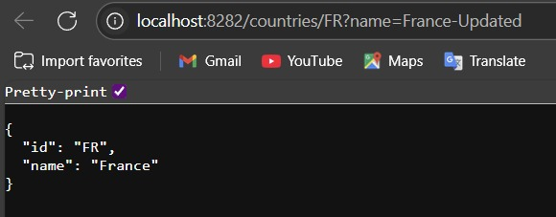

✅ ***Hands-On 8: Update country name based on code***

I developed a PUT endpoint to update the name of an existing country by its code, reusing the same repository and ensuring database updates reflect correctly.

**Tested Endpoints**

|  |  |  |
| --- | --- | --- |
| **Purpose** | **Method & URL** | **Example Response** |
| **List all countries** | GET <http://localhost:8282/countries> | JSON array of all Country |
| **Find by code** | GET <http://localhost:8282/countries/IN> | {"code":"IN","name":"India"} |
| **Add new country** | POST <http://localhost:8282/countries> Body JSON:{"code":"FR","name":"France"} | Returns the saved {"code":"FR","name":"France"} |
| **Update country name** | PUT <http://localhost:8282/countries/FR?name=France-Updated> | Returns {"code":"FR","name":"France-Updated"} |
| **Error if not found** | GET <http://localhost:8282/countries/ZZ> | HTTP 404 with body Country not found for code: ZZ |

**Outcome**:  
I ran the Spring Boot app on port **8282** and successfully tested all the endpoints with a browser, validating country retrieval, addition, and updating, while handling invalid codes gracefully.